Download eclipse using below link:

<https://www.eclipse.org/downloads/packages/release/2020-12/r>

after that u can see below option under this page

### [Eclipse IDE for Enterprise Java Developers](https://www.eclipse.org/downloads/packages/release/2020-12/r/eclipse-ide-enterprise-java-developers)

Under this click on Windows [x86_64](https://www.eclipse.org/downloads/download.php?file=/technology/epp/downloads/release/2020-12/R/eclipse-jee-2020-12-R-win32-x86_64.zip) on right side

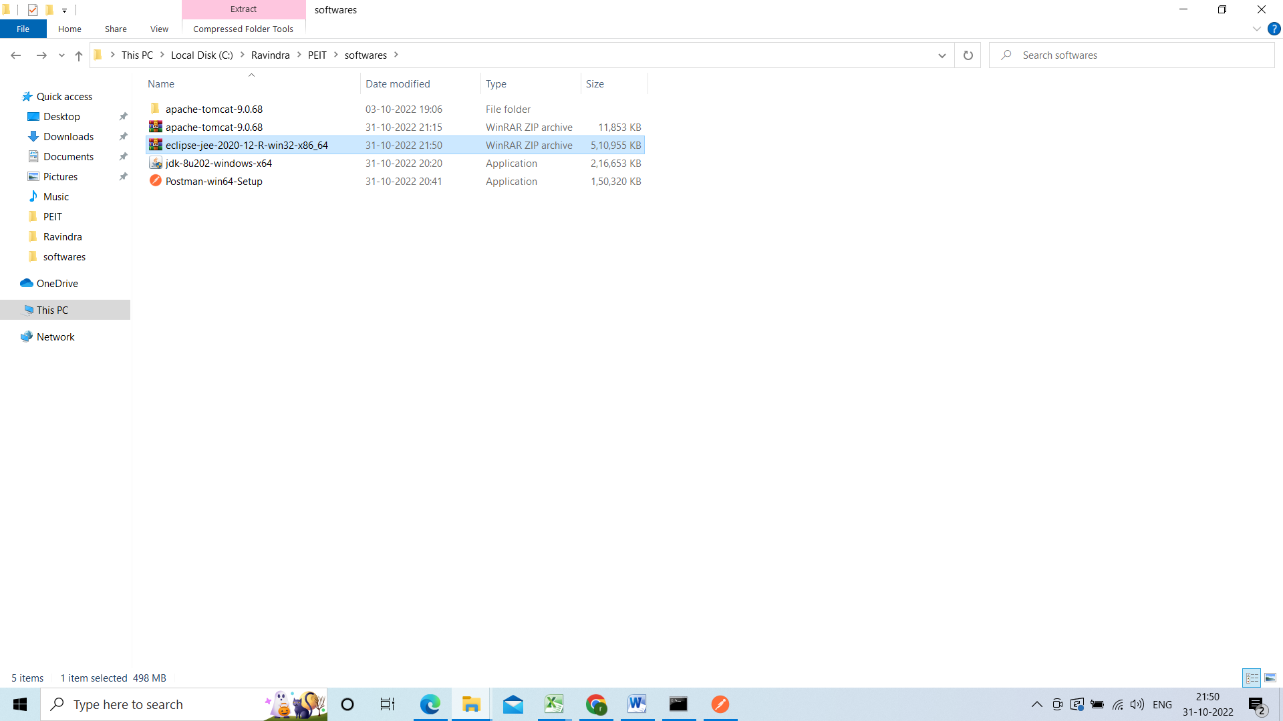

Extract it

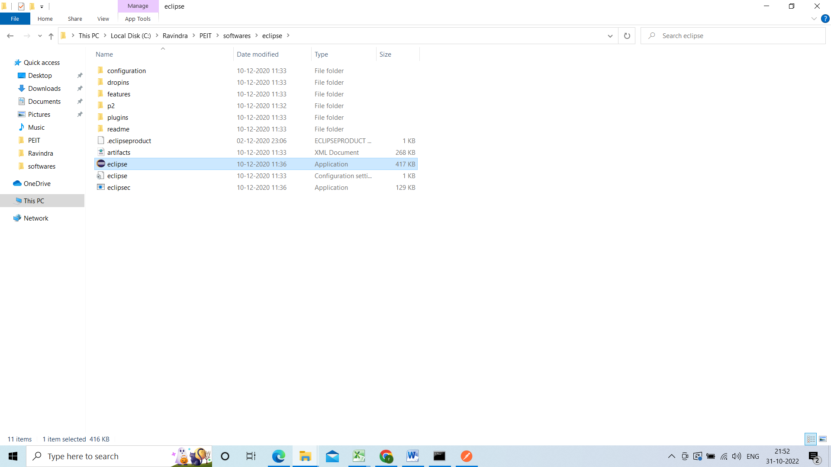

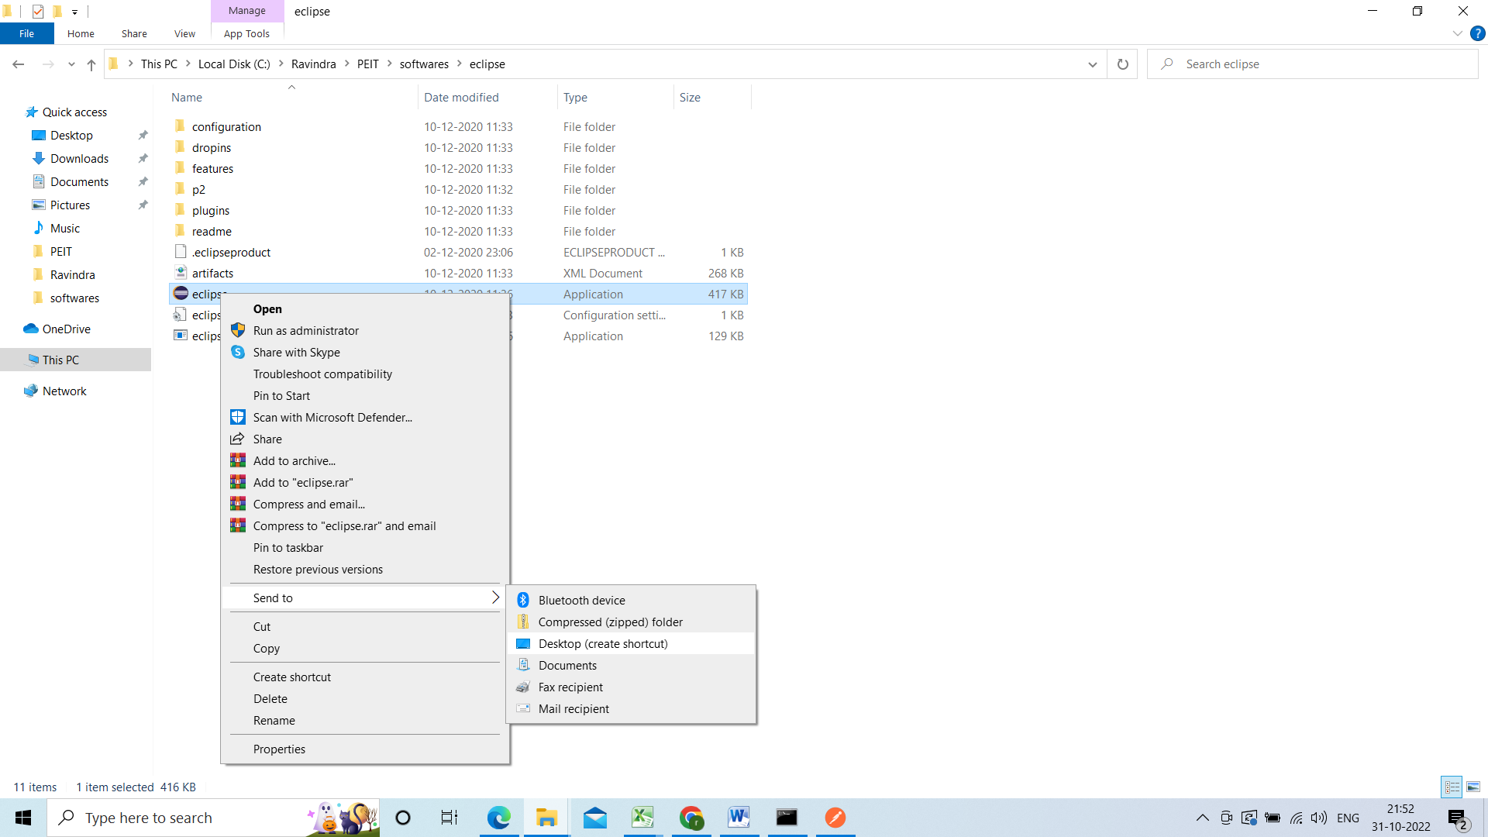

Right click on eclipse symbol and select send to desktop(shortcut) so that it will create the short cut in desktop.

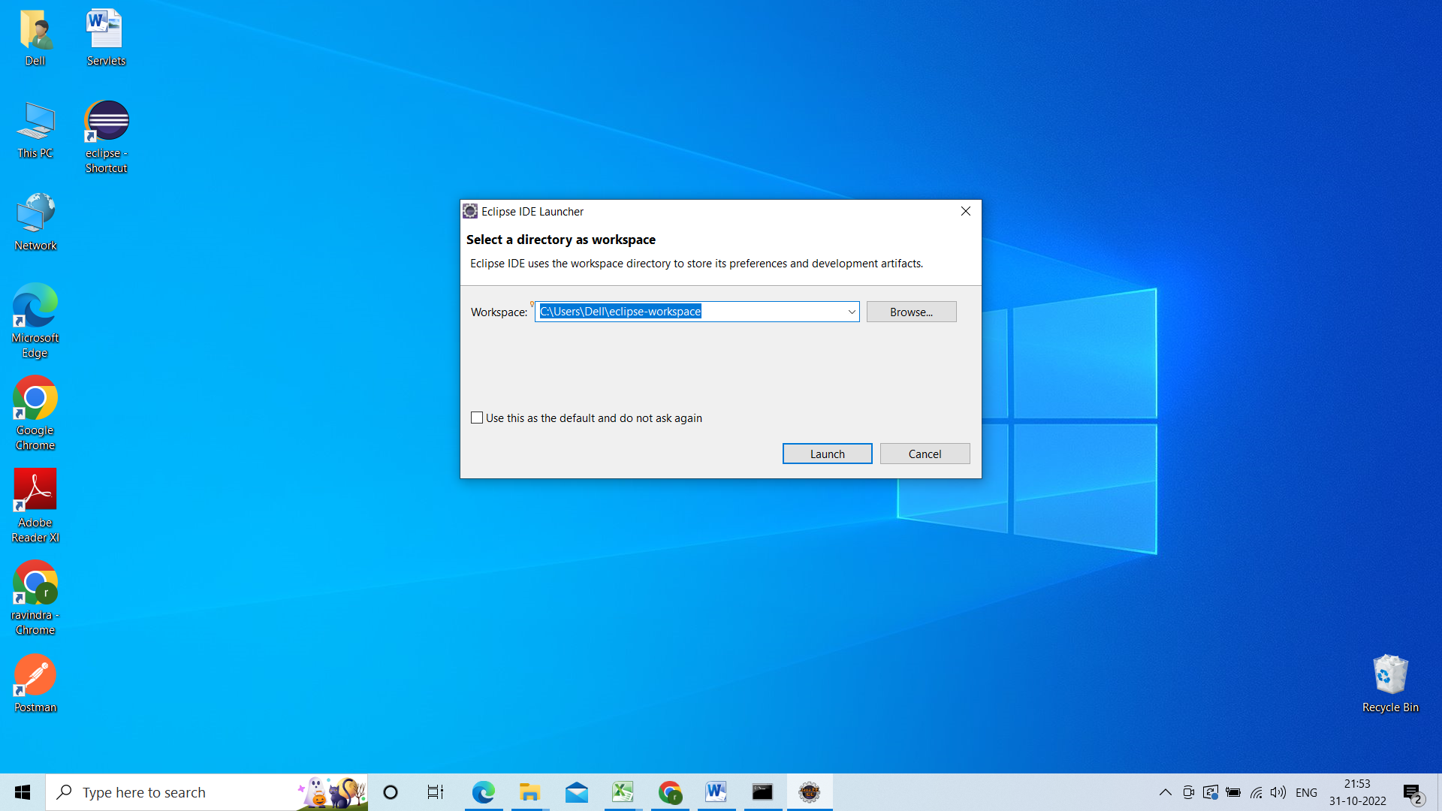

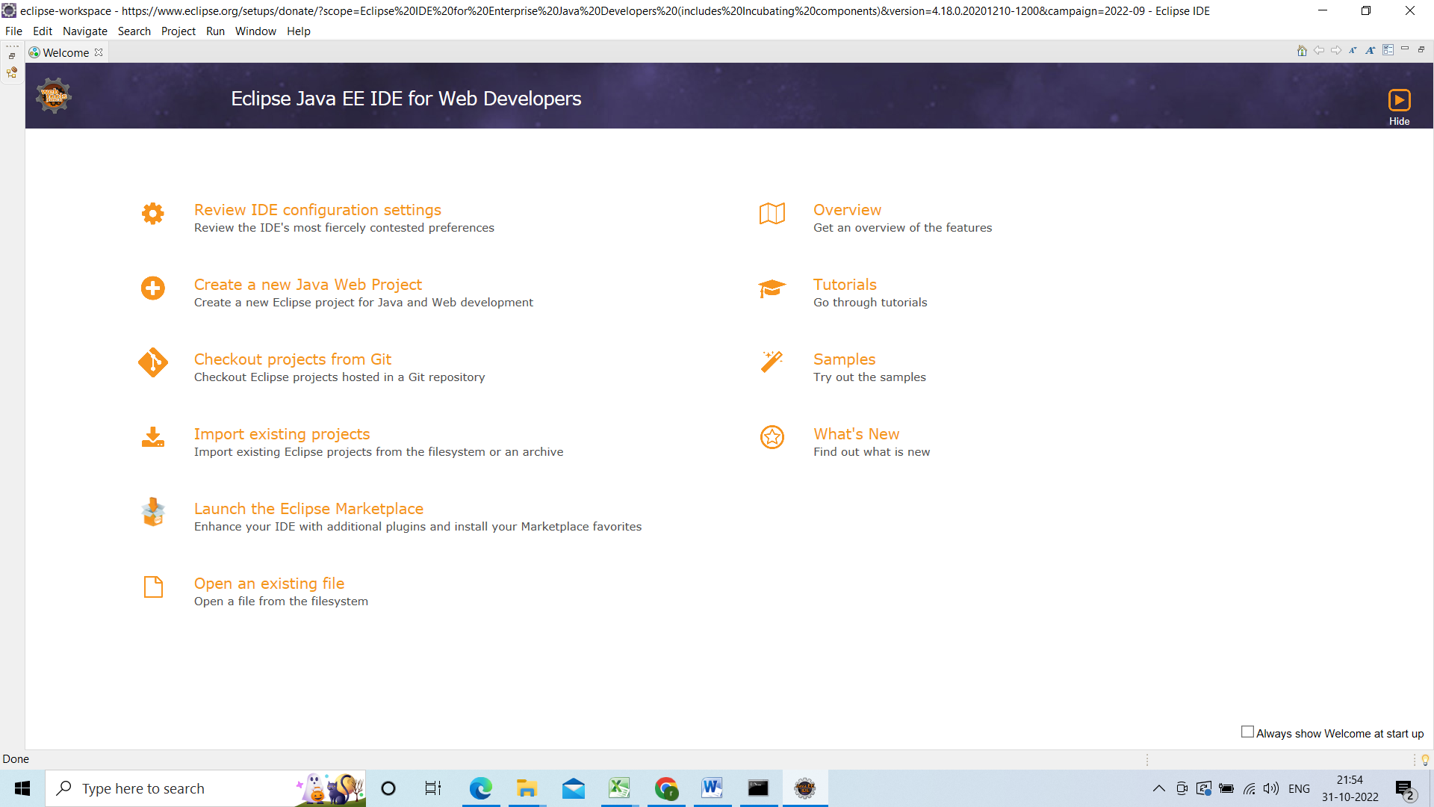

Close the welcome

How to Configure tomcat in eclipse:

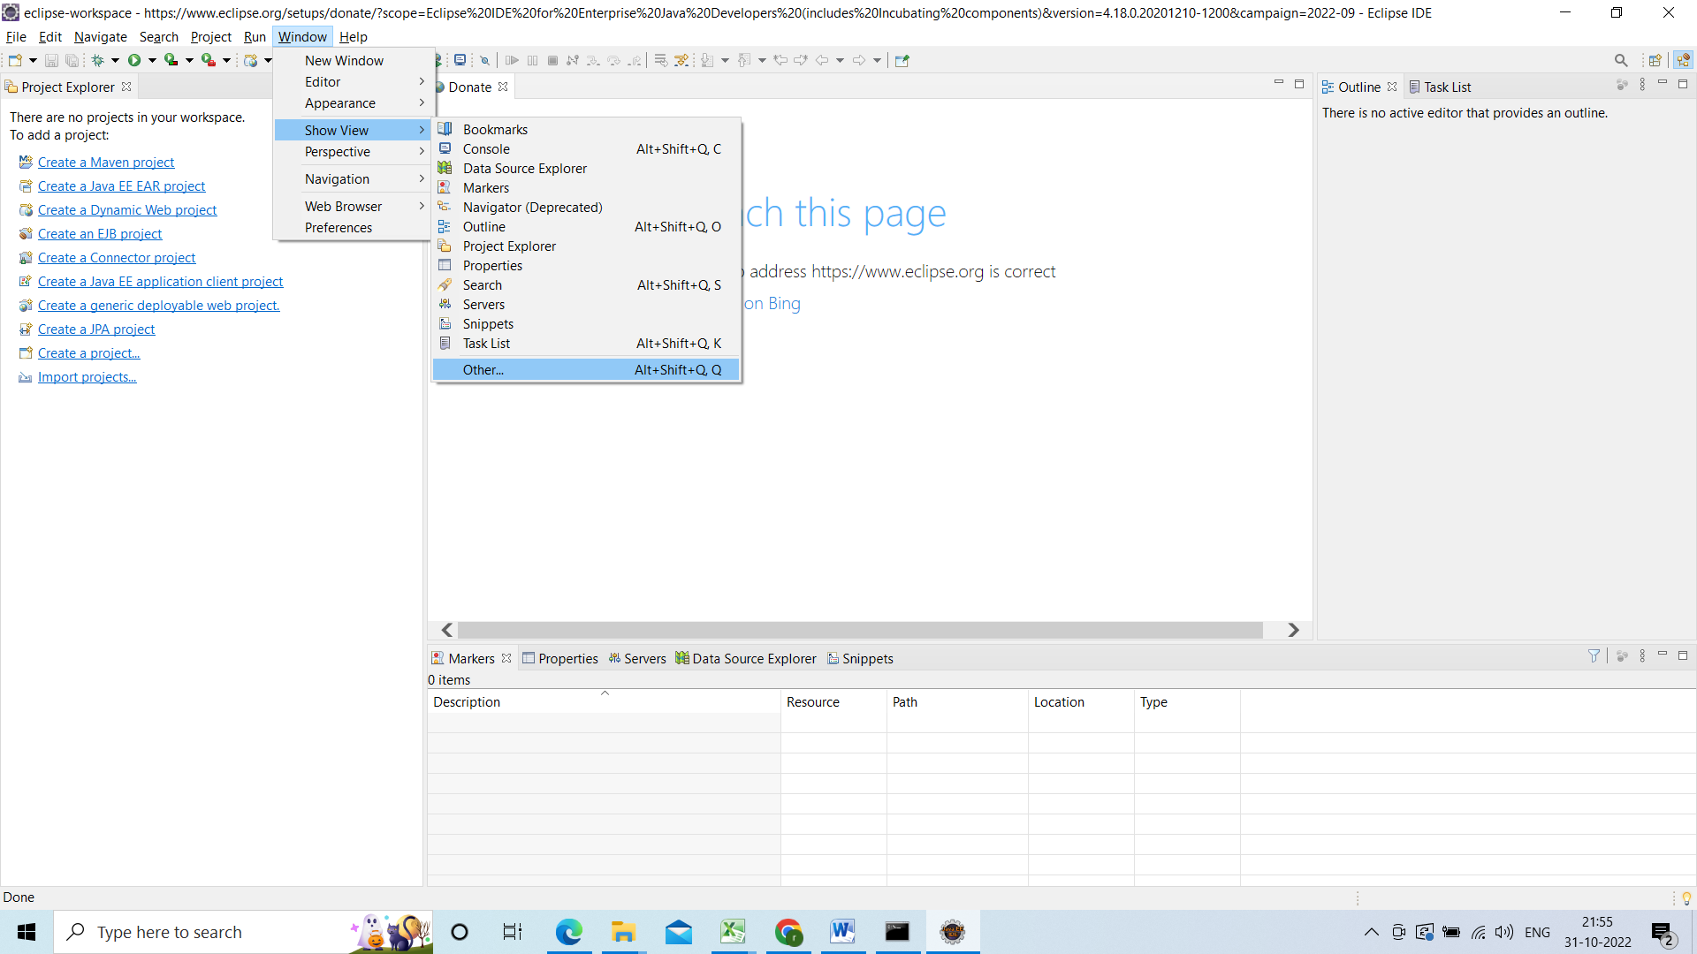

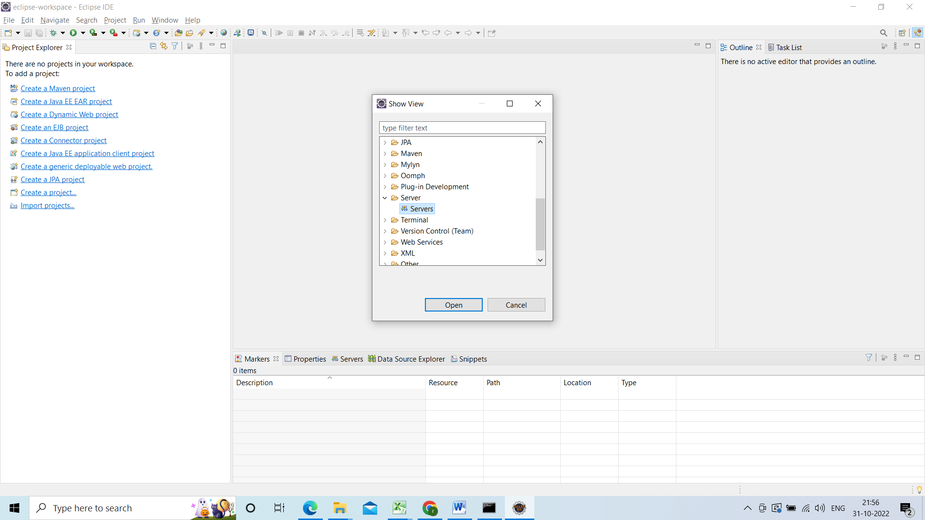

Select the servers and click on open

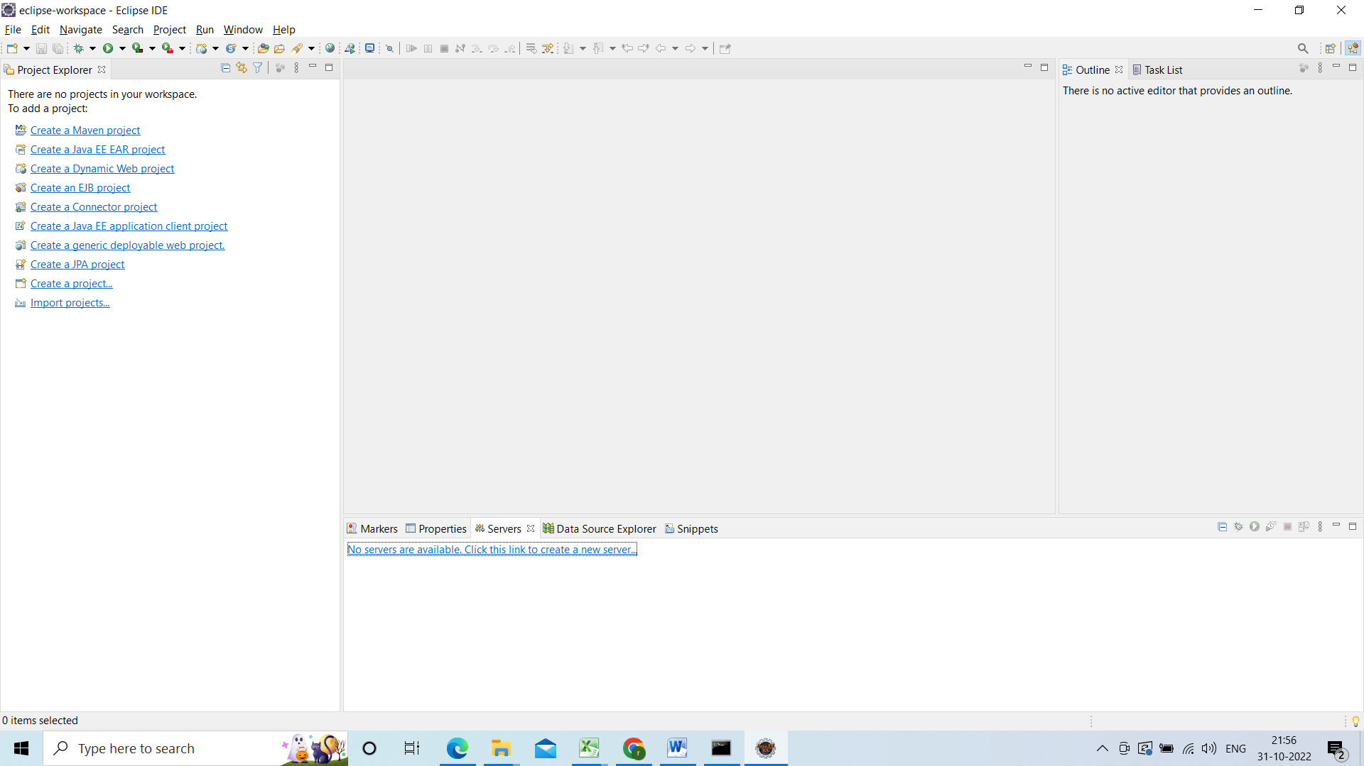

Under server tab

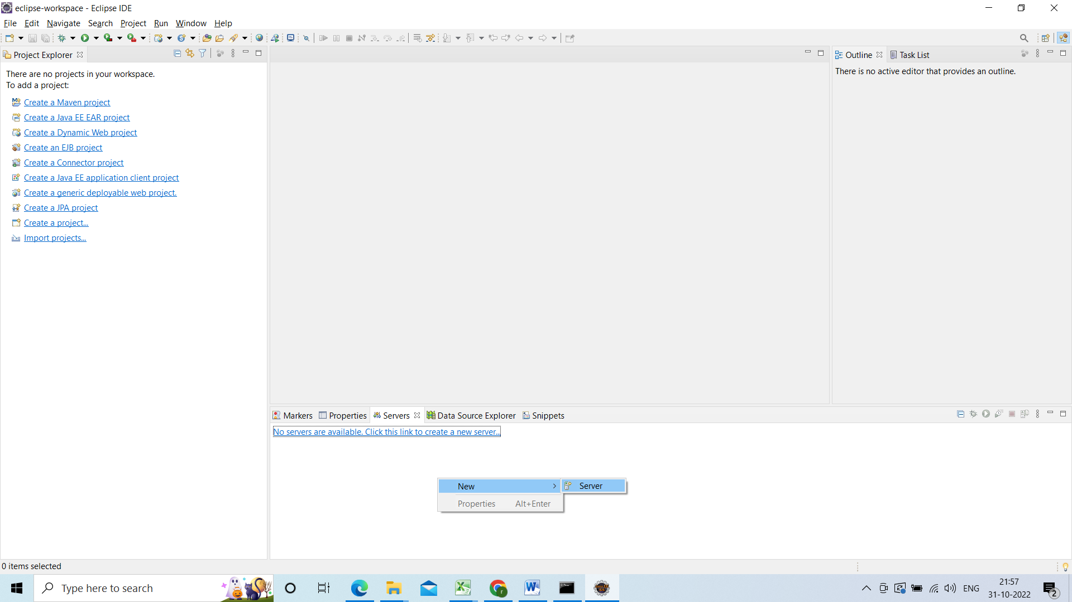

Right click select new server

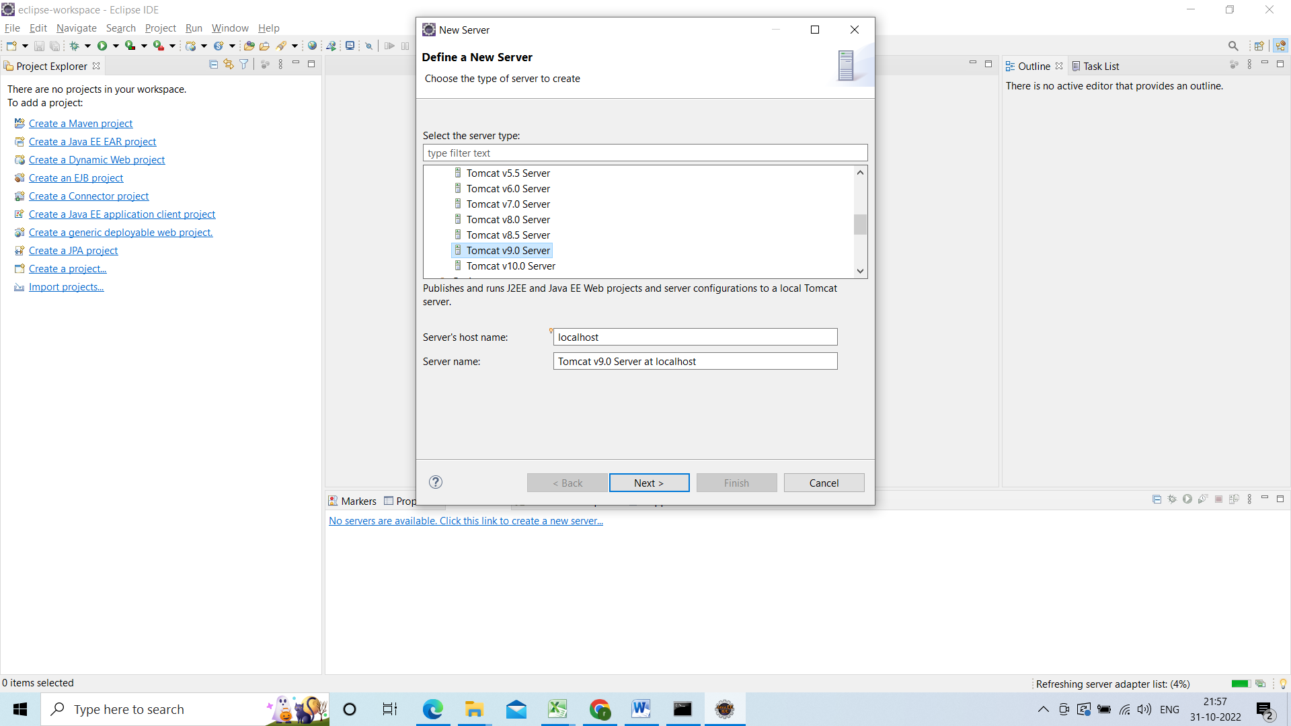

Click on next

And browse

Go to tomcat folder directory

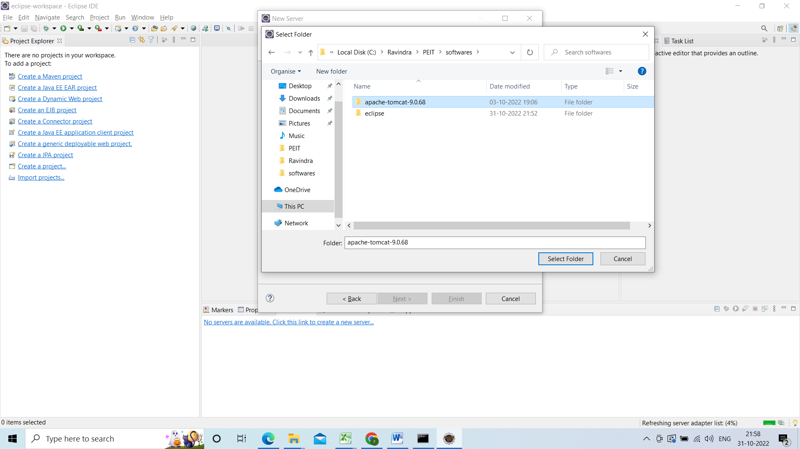

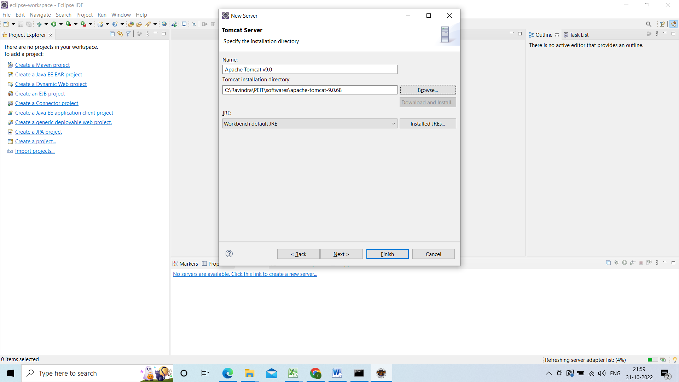

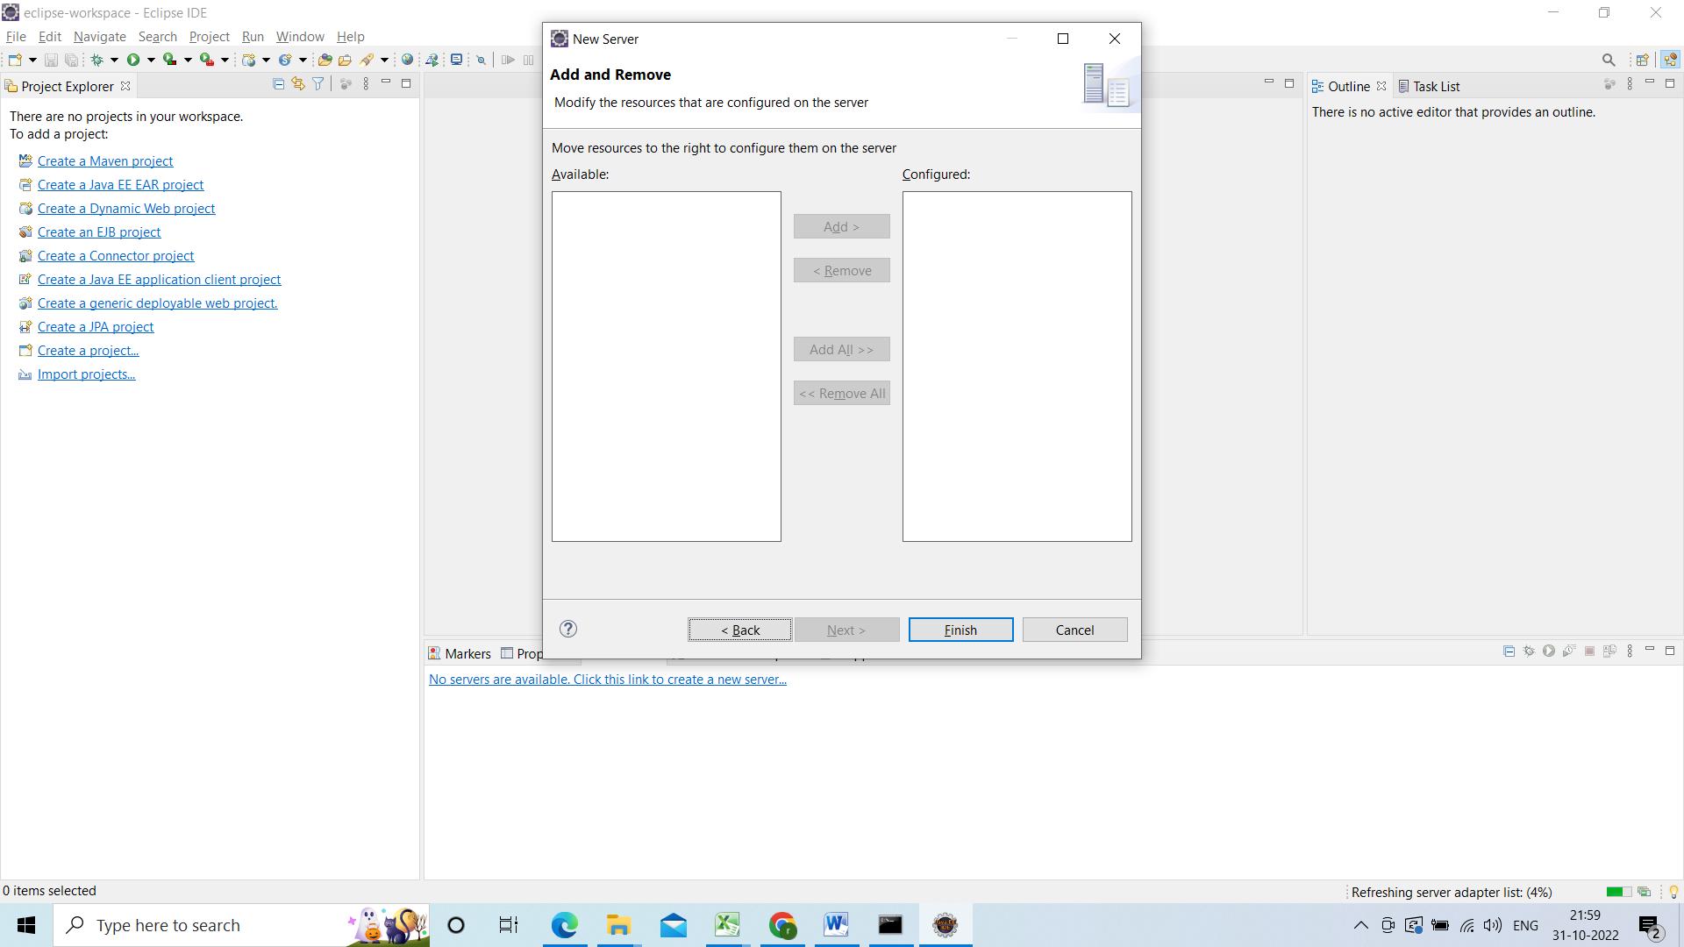

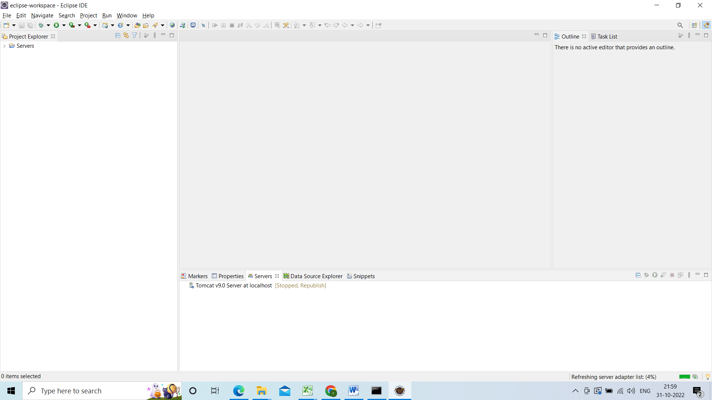

And start the server for testing for that right click on server click on start

